DAY 11 - C/C++ PROGRAMMING - HARSHINIE M

/*
Purpose : Demonstrate dynamic array allocation using new and delete with exception handling in C++
Author : Harshinie M
Date : 06/01/2026
*/

#include <iostream>
using namespace std;

// dynamic array

int main(){
int size;
int *arr;

cout << "Enter the size: ";
cin >> size;

try{
if (size <= 0)
throw size; // raising an exception

arr = new int[size]; // allocating the memory dynamically

for (int cnt = 0; cnt < size; cnt++)
arr[cnt] = 1001 + cnt; // filling the array

for (int cnt = 0; cnt < size; cnt++) // printing the data
cout << arr[cnt] << " ";
cout << endl;

delete [] arr; // freeing the memory
}
catch(int var){ // handling the exception
cout << "Caught int type Exception " << var << endl;
}

cout << "Executes normally even if exception occurs..." << endl;
}

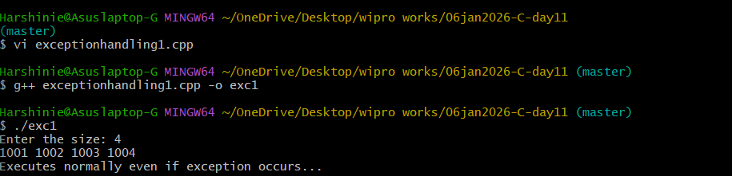
/*
Purpose : Demonstrate dynamic array allocation using a function with exception handling in C++
Author : Harshinie M
Date : 06/01/2026
*/

#include <iostream>
using namespace std;

// dynamic array function declaration
void createArray(int);

int main(){
try{
createArray(10); // create array of size 10
createArray(20); // create array of size 20
createArray(-120); // create array of size -120 (invalid)
createArray(200); // create array of size 200
}
catch(int var){ // handling the exception
cout << "Caught int type Exception " << var << endl;
}

cout << "Executes normally even if exception occurs..." << endl;
}

// Function to create a dynamic array
void createArray(int size){
if (size <= 0)
throw size; // raising an exception if size is invalid

int *arr = new int[size]; // dynamically allocate array

for (int cnt = 0; cnt < size; cnt++)
arr[cnt] = 1001 + cnt; // fill array with values

cout << "Array: ";
for (int cnt = 0; cnt < size; cnt++)
cout << arr[cnt] << " ";
cout << "\n************************************************\n";

delete [] arr; // free memory
}

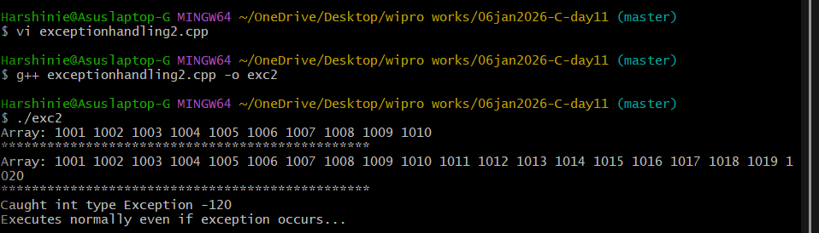

/*
Purpose : Demonstrate dynamic array creation using a function where each function handles its own exceptions so program continues even if some inputs are invalid
Author : Harshinie M
Date : 06/01/2026
*/

#include <iostream>
using namespace std;

// function declaration
void createArray(int);

int main(){
createArray(10); // create array of size 10
createArray(20); // create array of size 20
createArray(-120); // create array of size -120 (invalid)
createArray(200); // create array of size 200

cout << "Executes normally even if exception occurs..." << endl;
}

// Function definition
void createArray(int size){
try{
if (size <= 0)
throw size; // raise exception if size is invalid

int *arr = new int[size]; // dynamically allocate array

for (int cnt = 0; cnt < size; cnt++)
arr[cnt] = 1001 + cnt; // fill array

cout << "Array: ";
for (int cnt = 0; cnt < size; cnt++)
cout << arr[cnt] << " "; // print array
cout << "\n************************************************\n";

delete [] arr; // free memory
}
catch(int var){ // handle exception inside the function
cout << "Caught int type Exception " << var << endl;
}
}

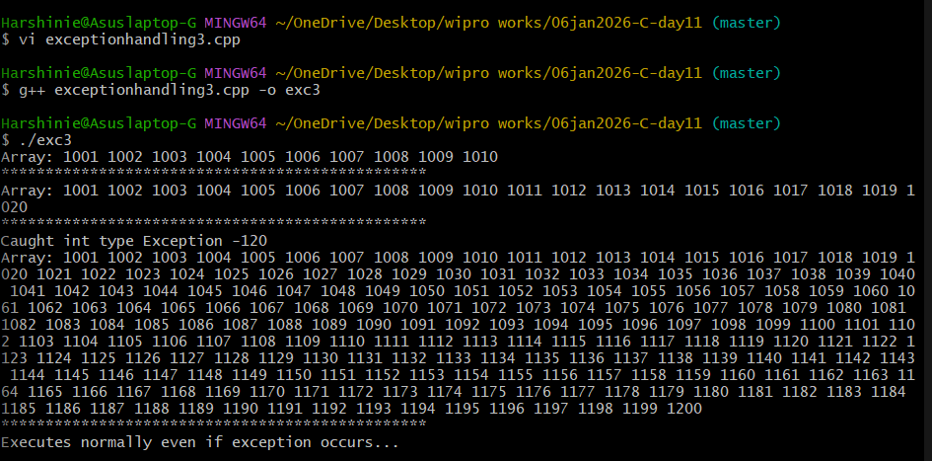

/*
Purpose : Demonstrate multiple catch blocks in C++ to handle different types of exceptions (int, double, unknown)
Author : Harshinie M
Date : 06/01/2026
*/

#include <iostream>
using namespace std;

int main(){
cout << "Outer statement #1" << endl;

try {
cout << "Inner statement #1" << endl;

throw 10; // throw an int exception
cout << "statement #2" << endl;

throw 104.34; // throw a double exception (this will never execute)
cout << "statement #3" << endl;
}
catch(int x){
cout << "Int type exception: " << x << endl;
}
catch(double x){
cout << "Double type exception: " << x << endl;
}
catch(...){
cout << "Caught unknown type" << endl;
}

cout << "Outer statement #4" << endl;
}

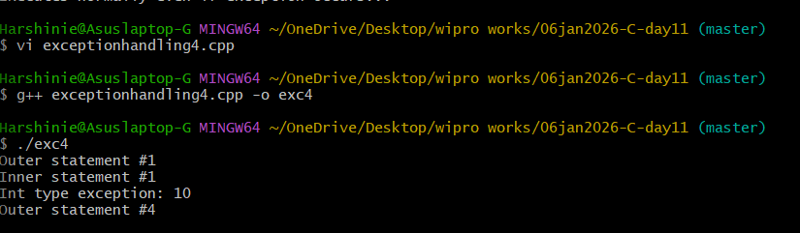

/*
Purpose : Demonstrate the use of set_terminate() and custom terminate handler when an exception is not caught
Author : Harshinie M
Date : 06/01/2026
*/

#include <iostream>
#include <cstdlib> // for exit()
#include <exception> // for set_terminate()
using namespace std;

// Custom terminate handler function
void funOne(){
cout << "void funOne() called..." << endl;
exit(1); // quits the program before abort() is called
}

int main(){
set_terminate(funOne); // register custom terminate handler

cout << "Outer statement #1" << endl;

try {
cout << "Inner statement #1" << endl;

// throw 10;
cout << "statement #2" << endl;

// throw 104.34;
cout << "statement #3" << endl;

throw 104.34f; // float exception (no matching catch)

cout << "statement #4" << endl;
}
catch(int x){
cout << "Int type exception: " << x << endl;
}
catch(double x){
cout << "Double type exception: " << x << endl;
}

cout << "Outer statement #5" << endl;
}

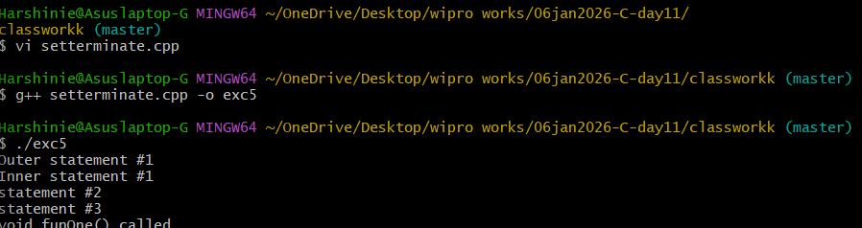

/*
Purpose : Demonstrate throwing and catching standard C++ exception (invalid_argument) using exception base class
Author : Harshinie M
Date : 06/01/2026
*/

#include <iostream>
#include <cstdlib>
#include <exception>
using namespace std;

int main(){

cout << "Outer statement #1" << endl;

try {
cout << "Inner statement #1" << endl;

throw invalid_argument("Message here"); // throw standard exception

cout << "statement #2" << endl;
}
catch(exception &e){ // catch base class reference
cout << e.what() << endl;
}

cout << "Outer statement #" << endl;
}

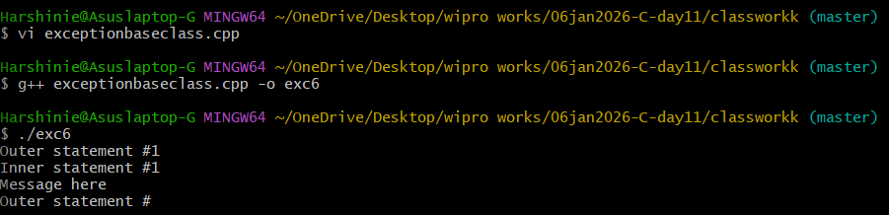

/*
Purpose : Demonstrate exception handling using derived (invalid_argument) and base (exception) class catch blocks in C++
Author : Harshinie M
Date : 06/01/2026
*/

#include <iostream>
#include <cstdlib>
#include <exception>
using namespace std;

int main(){

cout << "Outer statement #1" << endl;

try {
cout << "Inner statement #1" << endl;

throw invalid_argument("Message here"); // throw derived class exception

cout << "statement #2" << endl;
}
catch(invalid_argument &e){ // derived class catch
cout << "Derived: " << e.what() << endl;
}
catch(exception &e){ // base class catch
cout << "Base class: " << e.what() << endl;
}

cout << "Outer statement #" << endl;
}

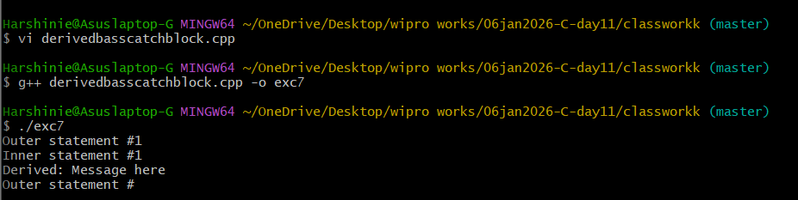

/*
Purpose : Demonstrate unwinding of stack during exception handling and how destructors of stack-based objects are called
Author : Harshinie M
Date : 06/01/2026
*/

#include <iostream>
using namespace std;

struct Test{
int data;

// Constructor
Test(int x) : data(x) {
cout << "Test(" << data << ")" << endl;
}

// Destructor
~Test() {
cout << "~Test()" << endl;
}
};

void recur(int);

int main(){
try{
recur(1);
cout << endl;
}
catch(int num){ // handling the exception
cout << "In main() Caught " << num << endl;
}
}

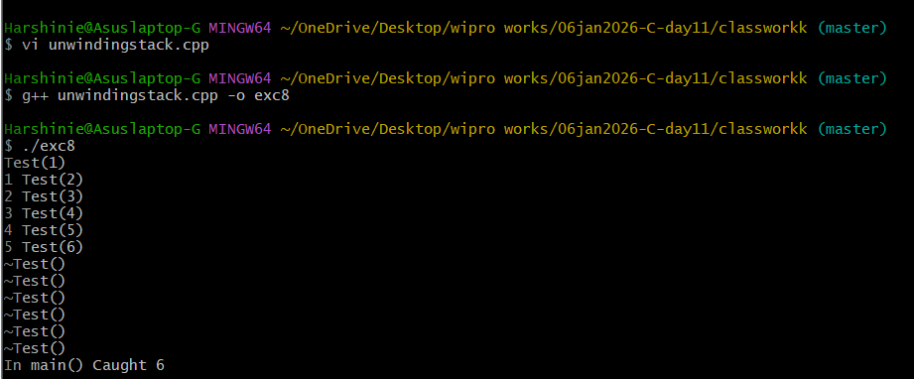

/*
Purpose : Demonstrate stack unwinding with a wrapper (RAII) class where heap memory is safely released during exception handling
Author : Harshinie M
Date : 06/01/2026
*/

#include <iostream>
using namespace std;

struct Test{
int data;
Test(int x):data(x){
cout << "Test(" << data << ")" << endl;
}
~Test(){
cout << "~Test()" << endl;
}
};

class Pointer{ // Wrapper (RAII) class
Test *ptr;
public:
Pointer(int x): ptr(new Test(x)) {}
~Pointer(){
delete ptr;
}
};

void recur(int);

int main(){
try{
recur(1);
cout << endl;
}
catch(int num){
cout << "In main() Caught " << num << endl;
}
return 0;
}

void recur(int num){
Pointer obj(num); // stack-based wrapper object

if(num <= 5){
cout << num << " ";
recur(num + 1);
cout << num << " ";
}

throw num; // exception is raised
}

